First thin in terraform is to create plugin that communicates with the respective cloud service provider.

Create the required files

At times, we need to run multiple versions of terraform, maybe for one repo one version for another repo another version etc. so to run multiple versions of terraform, we ause a tool called tfenv. Tfenv basically works for linux based machines like Linux OS and MAC OS. So for windows, you have to use git bash or wsl.
I used git bash. Ran the following commands:
git clone --depth=1 https://github.com/tfutils/tfenv.git ~/.tfenv
echo 'export PATH=$PATH:$HOME/.tfenv/bin' >> ~/.bashrc
source ~/.bashrc
(then install the reqd version of terraform)
tfenv install 1.12.1
But after running this, when I checked terraform version, via terraform version command, it showed 1.14.1 , so I have to use 1.12.1, the commands is
tfenv use 1.12.1
this switches default version to v1.12.1 .

finalyy the website is accessible with https visible

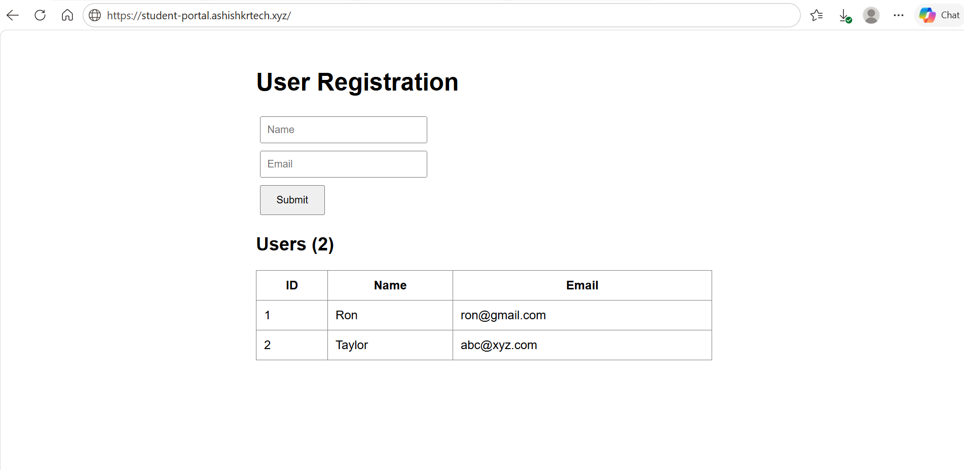

Database running
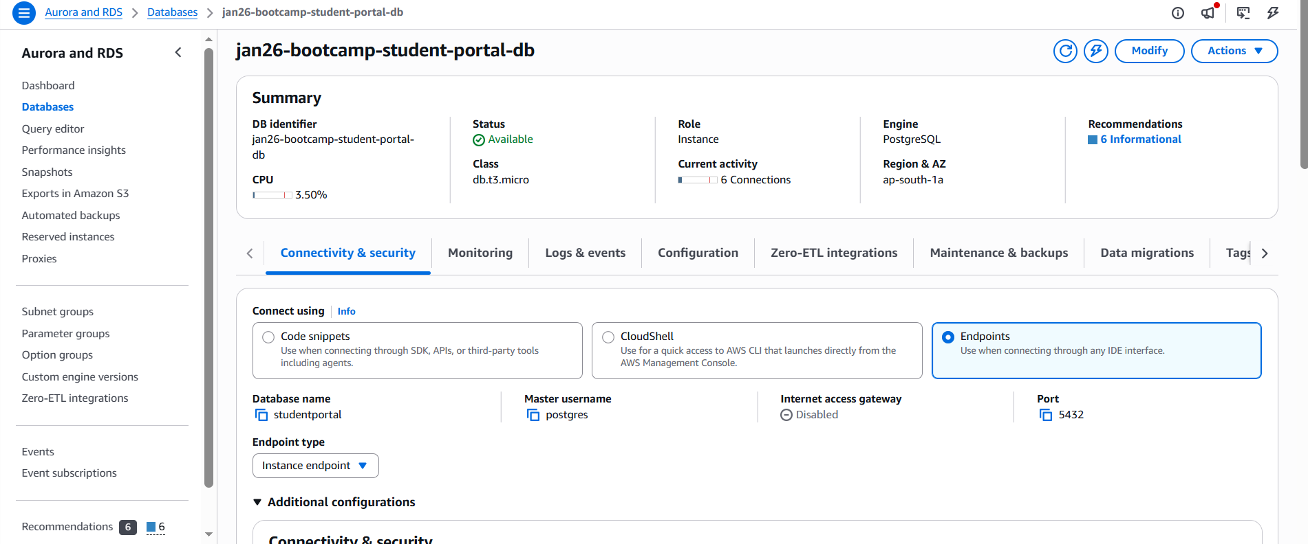

ECS service and tasks
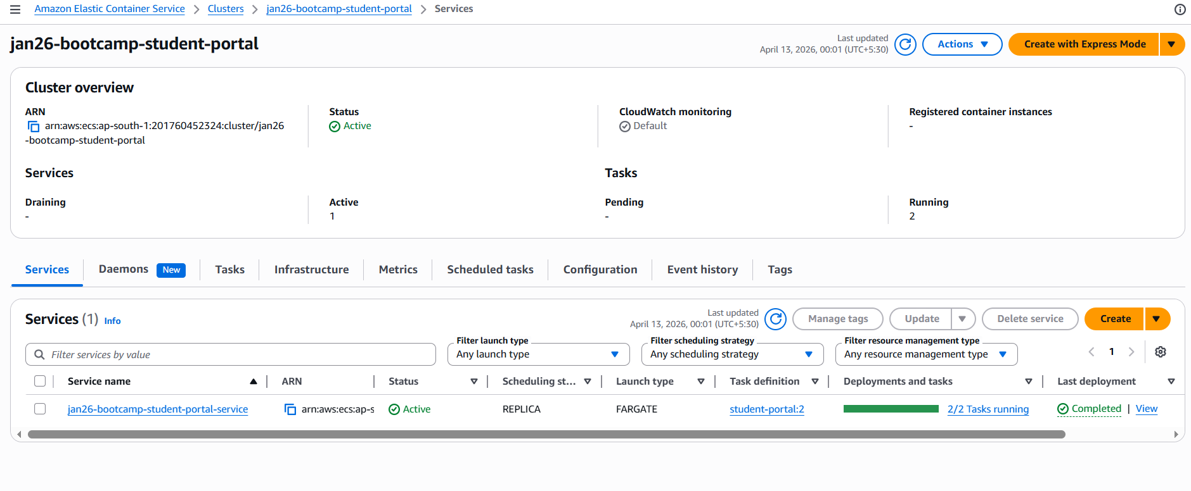

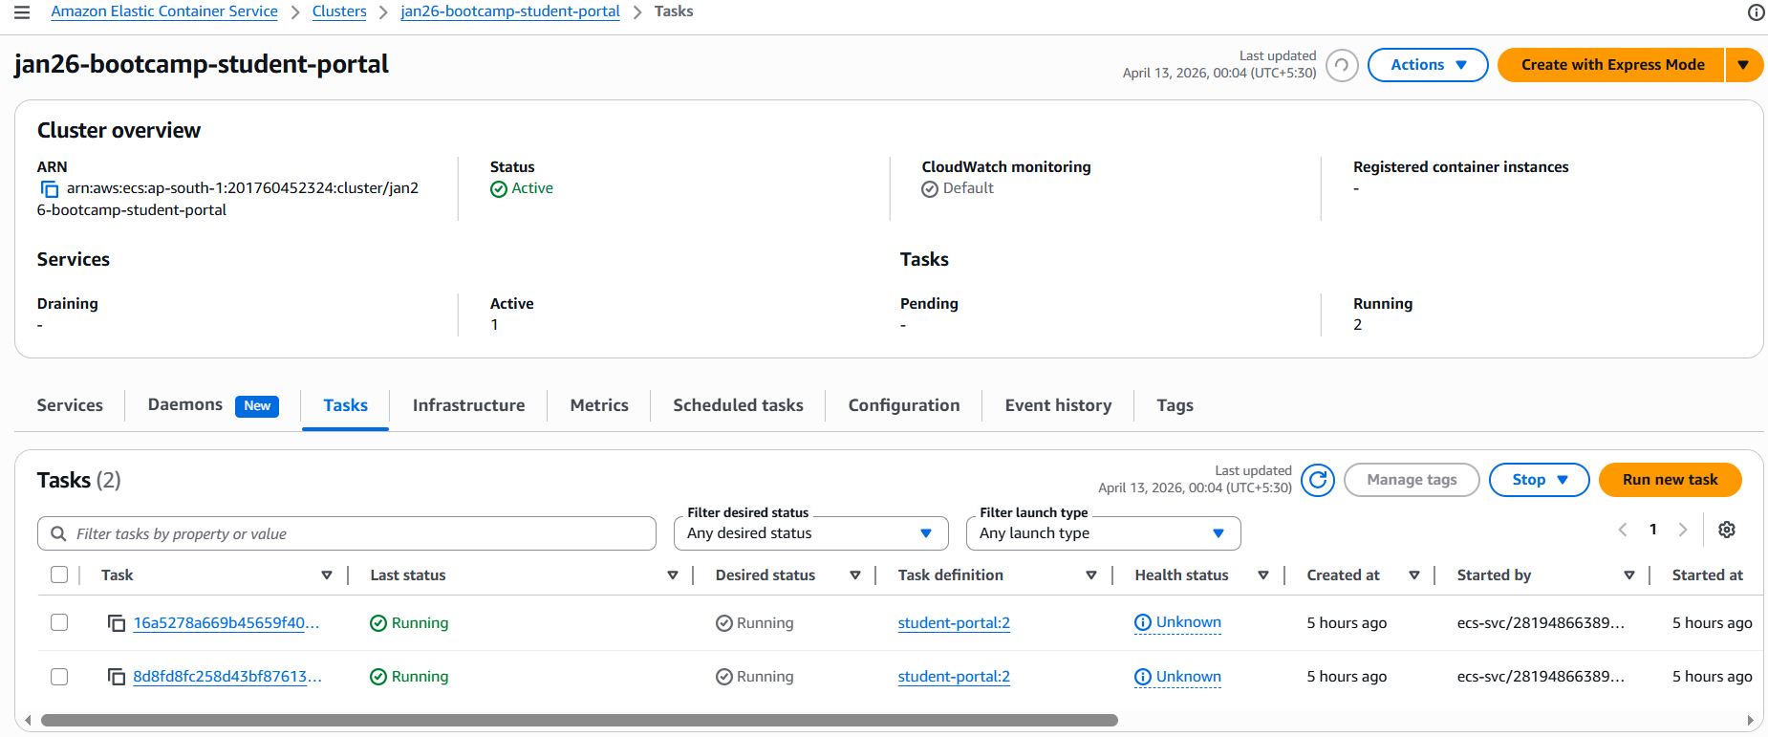

Load Balancers and Target group
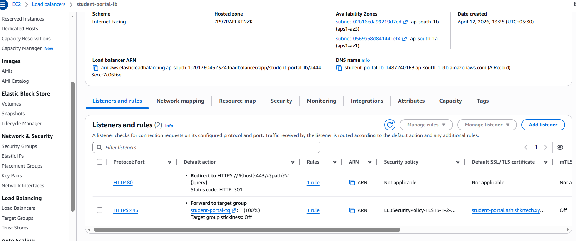

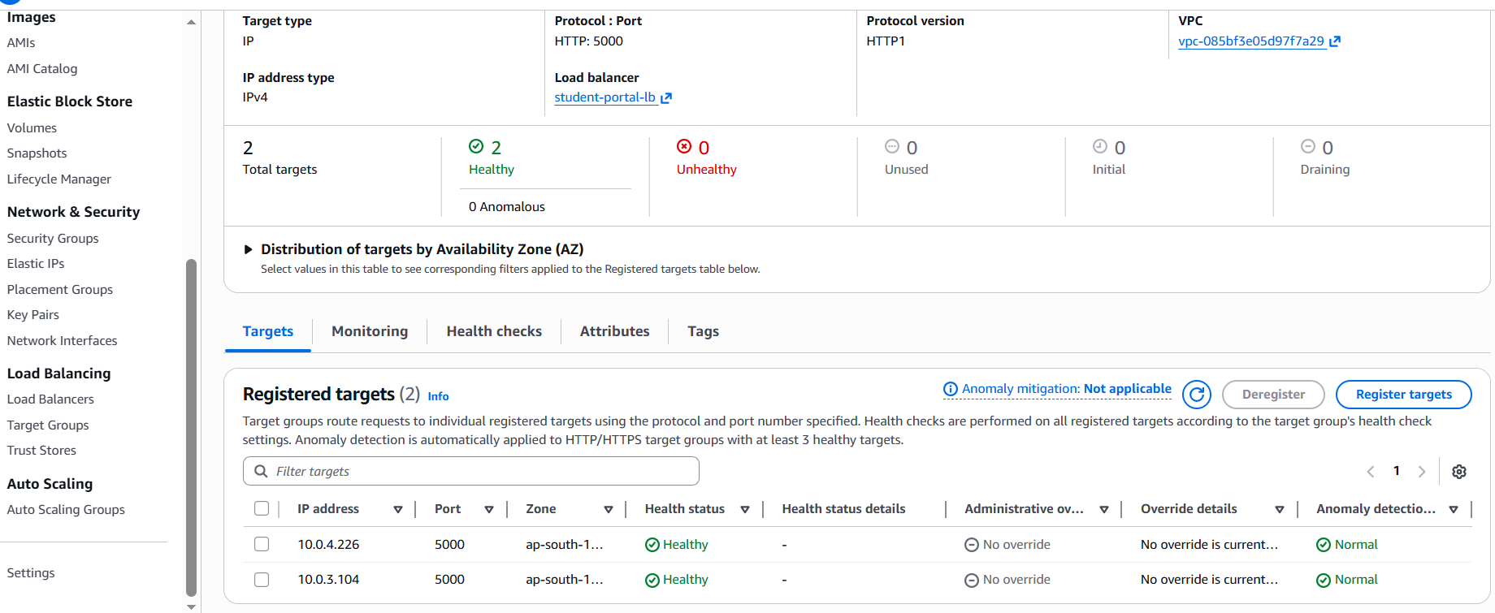

Route 53 and ACM
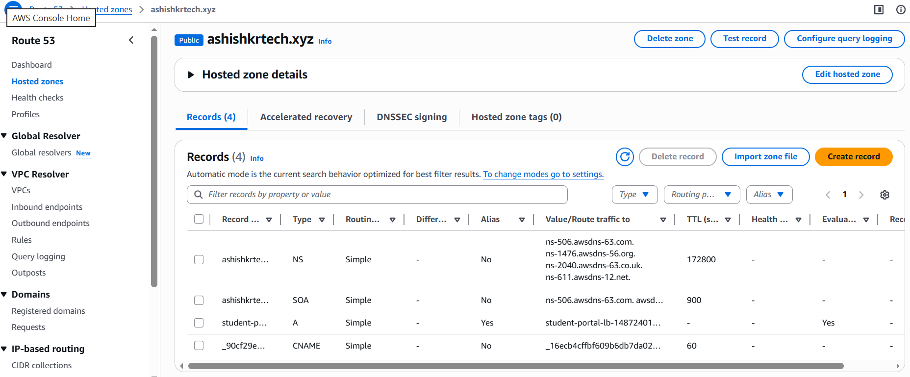

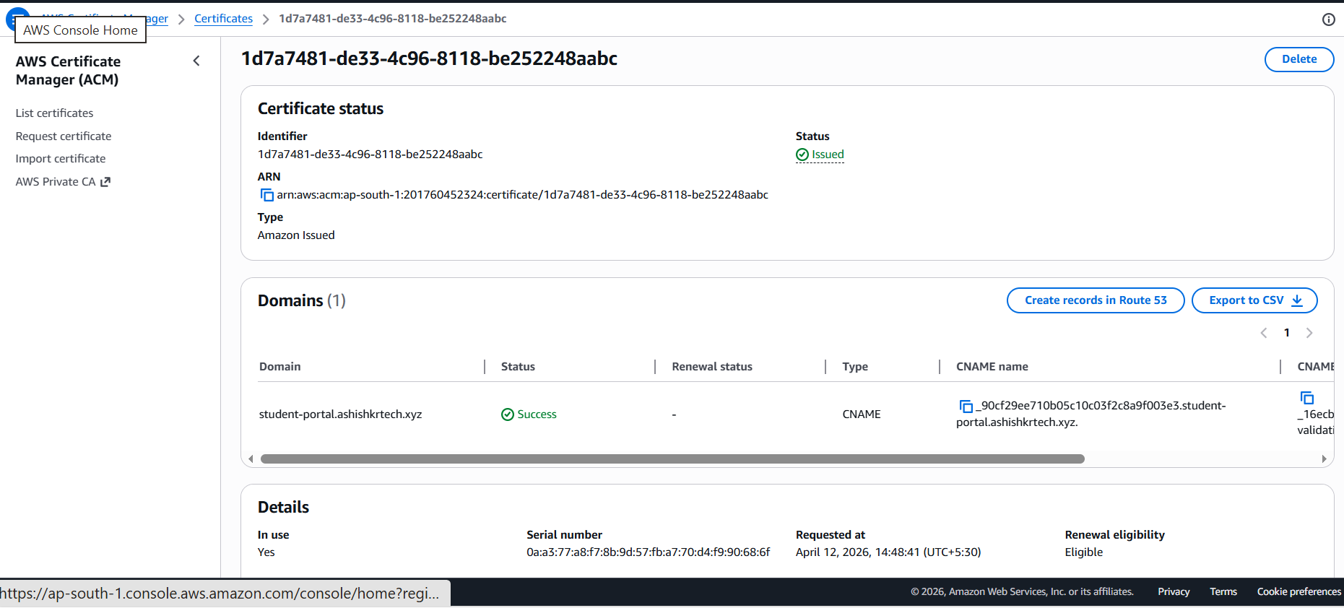

VPC and Subnets
